**Lab report 2 of DSD**



**Name:**

Adan Shahid

**Registration Number:**

2022-EE-119

**Submitted To:**

Ms. Shehzeen Malik

**Section:**

C

**Part (1):**

1. **Truth table of the given circuit:**

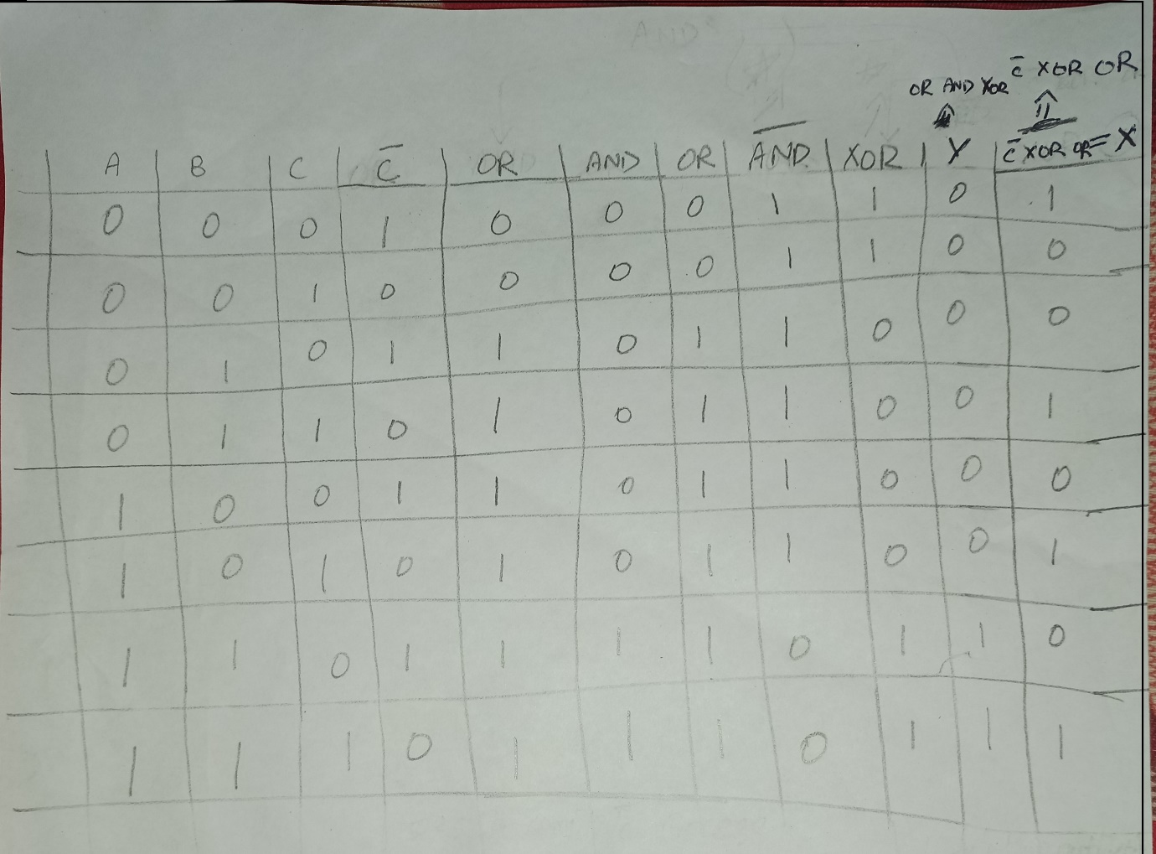

1. **Errors found in codes (Listings 4 and 5 given in manual):**

The error in listing 4 is that at line 9, we are not assigning “Sum”.

The error in listing 5 is that:

1. We don’t write “logic carry1” in line 6.
2. In line 7, we just write full_adder instead of “full_adder dut();”
3. In line 10, we are missing “&” between “(c(a^b))”.
4. Syntax error in line 15, we must write “initial begin” at the same line.
5. In line 18 to 33, there some mistakes related to name of variables. We must use “a1, b1, c1” instead of “a, b, c”.
6. Just before the “endmodule”, there is a word missing, that is “end;”, corresponds to line 15.
7. **Corrected code:**

**Listing 4**

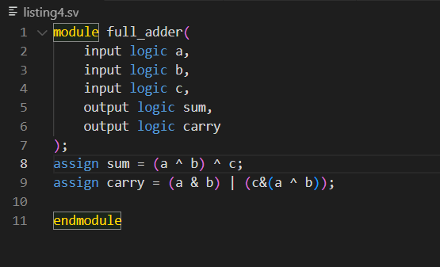

**Listing 5**

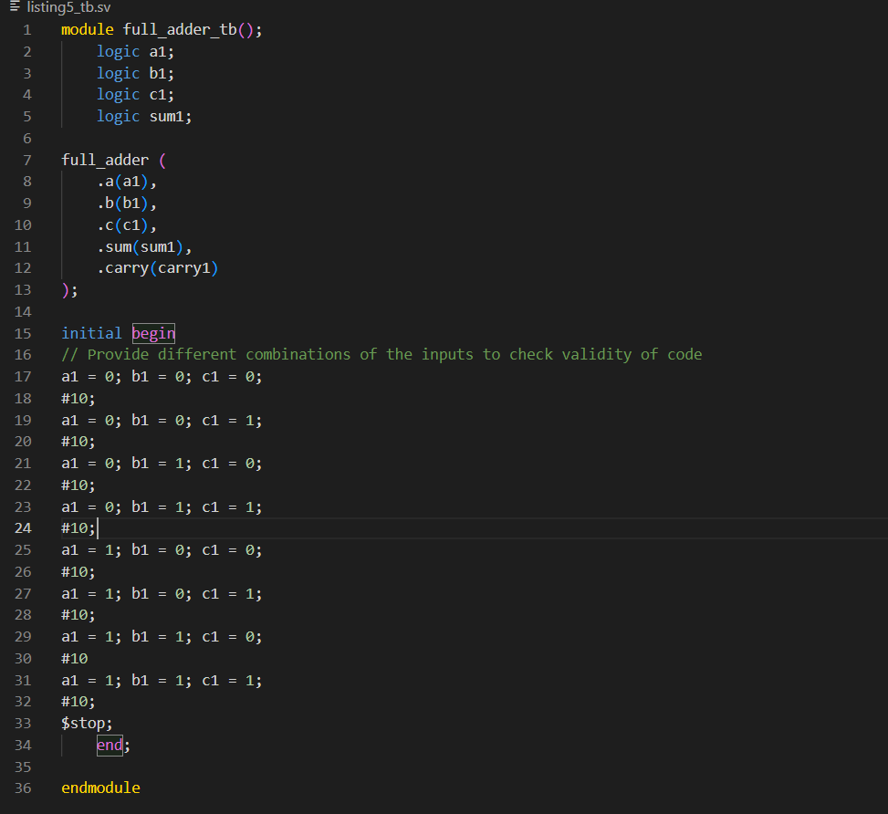

**Part (2)**

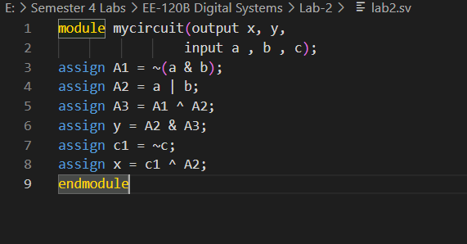

**Part (3)**

**Part (4)**

